**Team#9 project**

* **Idea**
  + Extension program that protects user privacy
* **How**
  + Scenario 1.
    - Users designate a list of privacy-sensitive websites
      * YouTube
      * Facebook
      * Google
    - Pop-up screens that notify types of data being collected and ask if a user wishes to proceed
      * Selective data sharing
        + provide dummy cookie → make personal data collection obsolete
  + **Scenario 2.**
    - Website that lists cookies → informing users (Naver, stackoverflow, google…)
* **Action item**
  + This week
    - all: understand how cookie works and search related papers (due: Sun 8pm)
  + Next week
    - Search and organize types of cookies collected from each site
    - Implement?
  + Third week
    - Execution & User interview
* **References**
  + <https://docs.google.com/document/d/13V-IzEHinsRtNV3j70S9k1mjvRMOi7_blNePkW3cdgs/edit>
* **Paper references**
  + [How cookies are used at Google](https://policies.google.com/technologies/cookies?hl=en-US)
  + [cookie tutorial](https://www.privacypolicies.com/blog/browser-cookies-guide/)
  + [GDPR compliance cookie](https://www.cookieyes.com/gdpr-cookie-consent/)
  + <https://blog.naver.com/clubyb/222037992777>

**Meeting (11.21)**

**Research Idea**

| **What**   * An instructive website that informs and guides users about data collection practices   **Why**   * Many websites are passively tracking and collecting user data (e.g., location, time of visit, visit frequency...etc) and these are usually done without much of the user awareness * Although legal practices such as GDPR require a detailed description of such collection and future usage, and such statements are mentioned in policies for personal information, people usually lack their knowledge or feel burdensome to go through * Most users lack knowledge on the following: how their data is being collected, what types of data are being tracked & collected, how it will be used w/whom while they browse through websites in their daily lives   **How**   * Informing   + Data collection, usage from several representative websites * website 분류 -- deeply using information * charts -- visual (categorize) |
| --- |

**Action item**

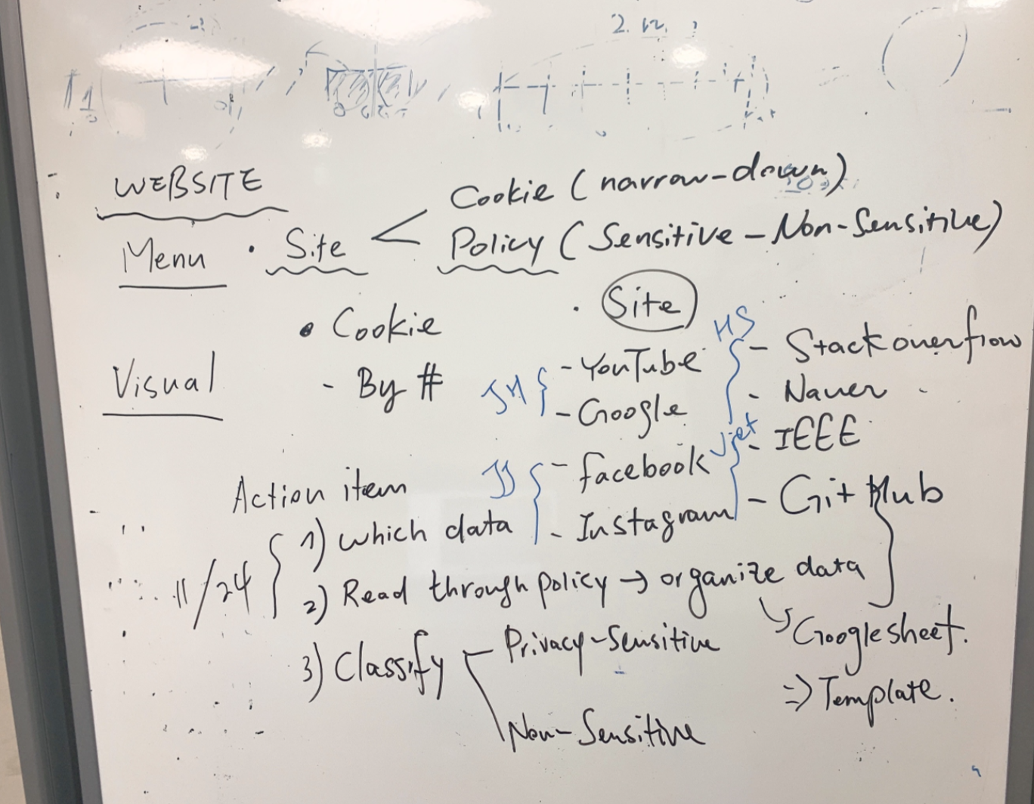

* ~~List data collection by each site~~ 
  + [link](https://docs.google.com/spreadsheets/d/1EGQuJZNXZSNijJMzM6Bxh--5mMpV3ZEPiS9Y9AlKogU/edit?usp=sharing)
  + [user survey](https://faculty.ist.psu.edu/xu/papers/Xu_etal_ICIS_2012a.pdf)
    - participant recruit (2-3 people each)
* ~~Classify data types → privacy-sensitive vs. non-sensitive data type~~
* Decide on design features
  + explain what the website is for
  + tabs
    - explain what the website is for
    - ask users their level of understanding
    - explanation on data collection (from each site)

→ plain text

→ divide by degree of sensitivity

→ list unique information to users

* Assign roles and schedule
  + Organize google sheet (everyone)
    - ~~fill up the information (due: tomorrow)~~
  + User survey
    - ~~finalize questionnaire (due: weekend, hyunsoo)~~
    - ~~recruit at least 2 people each (due: Monday, everyone)~~
  + Website
    - Reference design (due: weekend, everyone @slack)
      * overall design -- search
      * design features -- draw
  + Data classification
    - ~~sub-categories for data (due: weekend, hyunsoo)~~

z